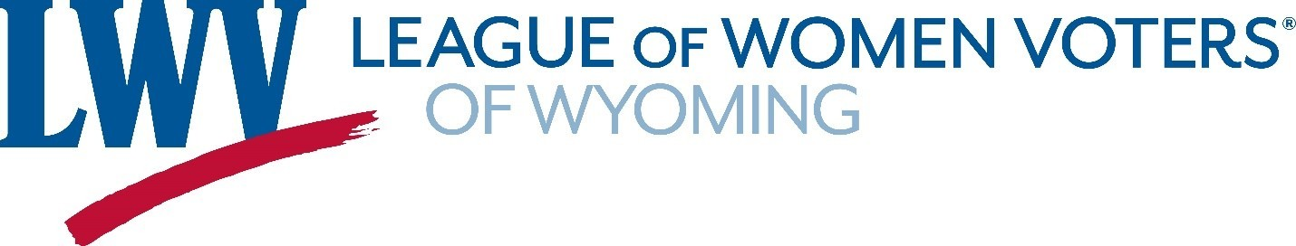
www.wyominglwv.org
info@wyominglwv.org

February 7, 2023

To: Wyoming Press Association, Wyoming Legislators, Wyoming Elected Officials, Wyoming press and media outlets
From: Nancy Lockwood, League of Women Voters of Wyoming President
RE: Op-ed: LWVWY response to proposed 2023 Wyoming voter registration and ballot legislation

The League of Women Voters of the United States believes voting is a fundamental right of citizens that must be guaranteed. Not only is voting a right, but it is also a responsibility vital to democratic self- government. It matters that people are engaged with their government, that they are informed, and that they vote. It also matters that they have confidence in the election process. And it matters that the election process be secure, accessible, and transparent to ensure this confidence.
Our state legislators have proposed many voter registration and ballot bills this session that appear to be motivated by a concern, even fear, that our election processes lack necessary safety measures to protect against voter fraud. Other bills unrelated to election security restrict a voter’s ability to vote for candidates of a party other than the voter’s registered party. Whatever their intent, these bills make it more difficult for people to carry out their right to vote for the candidate of their choice. A candidate who will be their governmental representative. The measures that are designed to provide security to the voting process are also barriers. They include limitations on:
- Who can provide voters with absentee ballots
- How voters obtain, complete, and return absentee ballots
- What type of identification is needed to obtain a ballot (absentee and at the polls)
- When changing party affiliation, shortening the allowed time period before an election in order to restrict cross-over voting.
Citizens have a right to vote in secure and accessible elections. Yet, a completely accessible election would sacrifice security and a maximally secure election would sacrifice access. Without evidence of security issues in previous elections, Wyoming law makers need to carefully consider the benefits and impediments to the right to vote when considering changes to our voting laws.
The Wyoming of Secretary of State’s office has stated Wyoming has no evidence of voter fraud and that our election systems are secure. Our current voter ID, registration, and ballot laws and election processes are working. There are no benefits to changing election laws for security purposes but there are significant drawbacks. These proposed changes stand in the way of Wyoming citizens’ fundamental right to receive a ballot and cast an informed vote for the candidates of their choice—candidates that represent and serve them in our democracy

